WebClothes Project Report

Corey Townsend, Michael Wheeler, William Orgertrice

**Introduction**

WebClothes is an e-commerce shopping website. It is built using HTML, CSS, javascript, MongoDB and the Django framework. It allows customers to browse through different pages to shop for the best online deals. WebClothes also has a shopping cart which takes the user to the checkout page where the customer’s data is processed. They are able to edit their profiles and personal information.

Webclothes is responsive, modern and stylish. It utilizes Material Design Bootstrap, jQuery and Bootstrap for the front-end design. MongoDB and Python are used for the back-end design.

**Topic**

The topic is an e-commerce website written in Django with a MongoDB database that allows the user to sign in, order items to their cart and checkout.

**Scope**

The scope of the project is to allow customers to log in, add to their cart, checkout and edit their information.

**Implementation**

Django’s framework allows for the use of dynamic websites that are created as opposed to static websites that are written using redundant code. The data is stored and accessed through a NoSQL database management system called MongoDB. In order to run the server you need to have MongoDB, Python version 3.5 or higher and pip installed on your computer.

Add both technologies’ path to your enviornment variables. To install pip use the commad get-pip.py in your terminal. Use the command pip install django to install django. Navigate to the project’s directory. Use the commands mongod and python manage.py runserver in that order. You need to have your database to be running in order to run your django server.

When the django server starts you can use localhost:8000 to view the website’s home page. You can navigate to the admin portal by adding “/admin” to the home page url. By logging in and using the posts collection you can add or delete a post that will update the WebClothes MongoDB database.

**Use cases**

|  |  |
| --- | --- |
| **Name:** | **User Login** |
| **ID:** | **UC_001** |
| **Created By:** | **William Orgertrice** |
| **Date Created:** | **12/2/2018** |
| **Description:** | **While the user is on the home page or a browsing page, the user is allowed to sign in or sign up using a single sign-on form.** |
| **Actors:** | **User** |
| **Benefits:** | **Single sign-on enables users to access all of their applications from one location, with a single set of credentials.** |
| **Frequency of Use:** | **100% of users will do this once every thirty days after the initial sign in.** |
| **Triggers:** | **When the user clicks login on the home page or on a browsing page** |
| **Preconditions:** | **The user is on the home page or a browsing page.** |
| **Postconditions:** | **The MongoDB server stores their login information.**  **The username is shown at the top of the screen.**  **The user is able to order clothes.** |
| **Exceptions:** | **1. The user is already logged in.**  **2. Incorrect credentials** |

|  |  |
| --- | --- |
| **Name:** | **Visit a Site** |
| **ID:** | **UC_002** |
| **Created By:** | **William Orgertrice** |
| **Date Created:** | **12/2/2018** |
| **Description:** | **While the user is on the home page, they can go to a browsing page to view clothes.** |
| **Actors:** | **User** |
| **Benefits:** | **Users can browse pages to view clothes and accessories.** |
| **Frequency of Use:** | **Users will do this every time they want to browse for clothing after they sign in.** |
| **Triggers:** | **When the user clicks the search bar or a nav item in the navbar** |
| **Preconditions:** | **The user is on the home page or a browsing page.** |
| **Postconditions:** | **The username is shown at the top of the screen.**  **The user is able to order clothes.** |
| **Exceptions:** | **The user is not logged in.** |

|  |  |
| --- | --- |
| **Name:** | **Logout** |
| **ID:** | **UC_003** |
| **Created By:** | **William Orgertrice** |
| **Date Created:** | **12/2/2018** |
| **Description:** | **While the user logged in they can click the logout button to logout.** |
| **Actors:** | **User** |
| **Frequency of Use:** | **100% users who want to logout will use this to logout.** |
| **Triggers:** | **When the user clicks logout on the home page or on a browsing page** |
| **Preconditions:** | **1. The user is logged in. 2. The user no longer wants to be logged in.** |
| **Postconditions:** | **1. The user is logged out** |
| **Exceptions:** | **N/A** |

**Conclusion**

In conclusion, WebClothes is a sleek and effiecent e-commerce website that offers affordable clothing. It’s website was designed by college students and has a modern touch to it. WebClothes was developed with a mobile-first ideology so it is responsive.

**References:**

“Documentation.” *FAQ: General | Django Documentation | Django*, docs.djangoproject.com/en/2.1/.

“The MongoDB 4.0 Manual¶.” *In-Memory Storage Engine - MongoDB Manual*, docs.mongodb.com/manual/?_ga=2.102986755.2079521037.1543794802-1443163624.1540349196.

Schafer, Corey. “Python Django Tutorial: Full-Featured Web App Part 1 - Getting Started.” YouTube, YouTube, 31 Aug. 2018, www.youtube.com/watch?v=UmljXZIypDc.

“Bootstrap Material Design UI KIT - World's Most Popular &amp; Free UI Framework.” Material Design for Bootstrap, mdbootstrap.com/docs/jquery/.

https://github.com/Williamovero/WebClothes

## Home Page

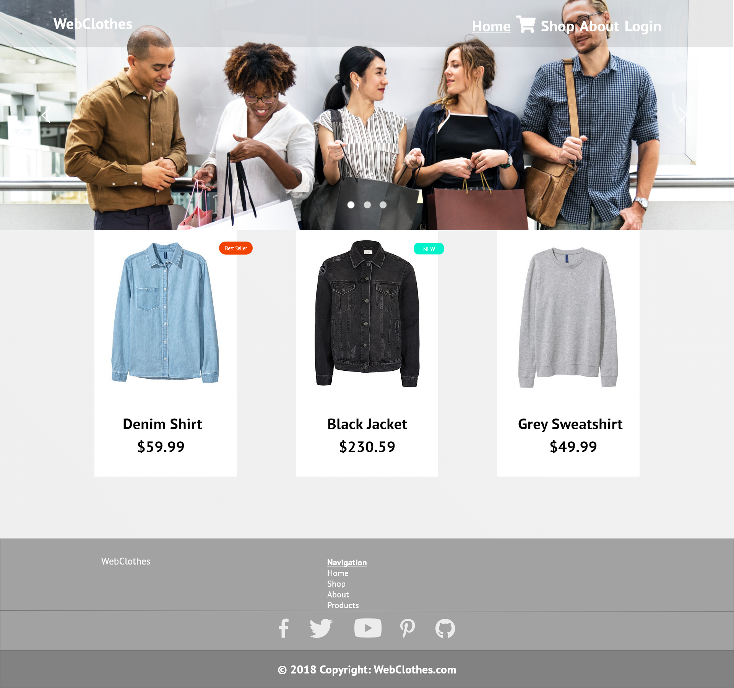

## Login Page

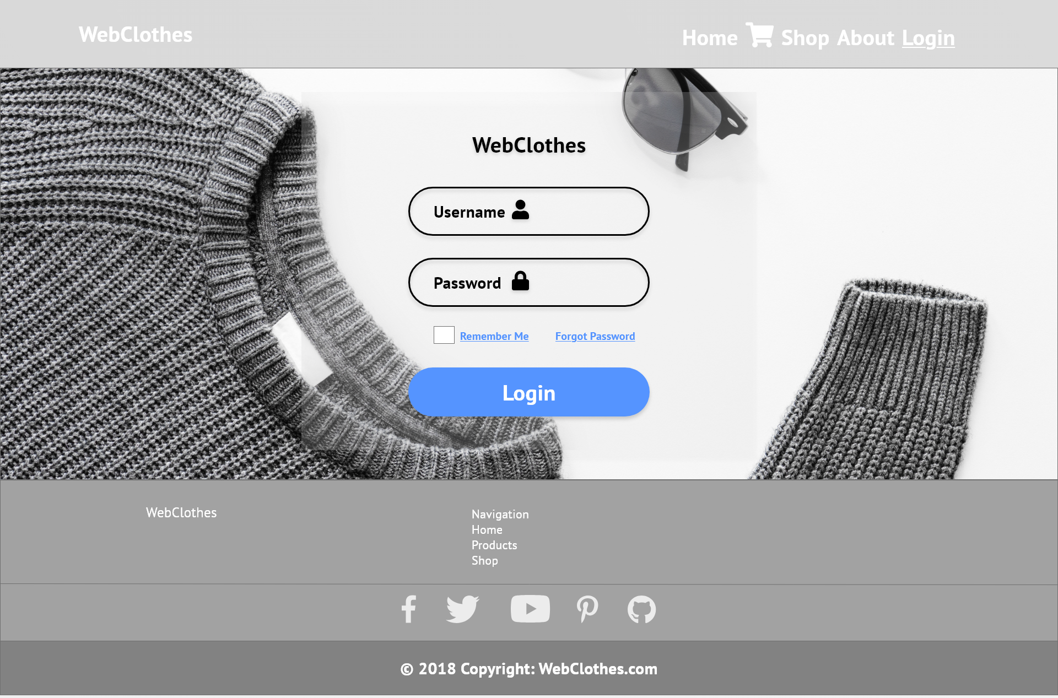

## Checkout Page

